Lessons learnt in assignment 3 and 4

- exit(0) in bash can be used as --> exit 0
however we can’t use $exit or $quit -this makes the entire terminal(console) to exit
(similar to Alt+F4)
here exit 0 will only exit the program being executed and not the entire terminal
- #syntax of Switch cases in bash
#HERE IF YOU USE A SINGLE ; INSTEAD OF DOUBLE ;; THEN IT WILL FALL THROUGH(similar to not us)

case “$c” in
“<string to be matched>”) #commands to be executed
;;
“<string to be matched>”) #commands to be executed
;;
“<string to be matched>”) #commands to be executed
;;
*) #commands to be executed //this is the default case ;;

#for example code for menu driven program
#the below need not be numbers only it can be strings also

while [ 1 ]
do

echo "choice ?"
read c
case $c in
"1") /*echo "enter the name"
read name
echo "enter roll number"
read roll
echo "enter semester"
read sem
echo "enter the marks in three subjects"
read marks
echo -e "$name $roll $sem $marks \n" >> record
*/;;
"2") /*echo "enter the name whose record is to be deleted"
read name
grep -v "$name" record > record
*/;;
"3") /*echo "enter the name to be found in the record"
read name */
;;
"4") exit 0 ;;
*) <default commands to be executed> ;;
esac
done

- while using expr leave spaces between variables or else it gives error
i.e $n/10 gives error
whereas $n / 10 doesn’t give error

- while using while use [ ] instead of ()
#while () gives error
- while writing condition in while or any other loop inside [ ] leave spaces between the terms also and leave spaces after and before [ and ] respectively
i.e [<space>term<space>operation<space>term<space>]
- dont forget to put esac at the end of case
- how to check whether a string is present in a file or not
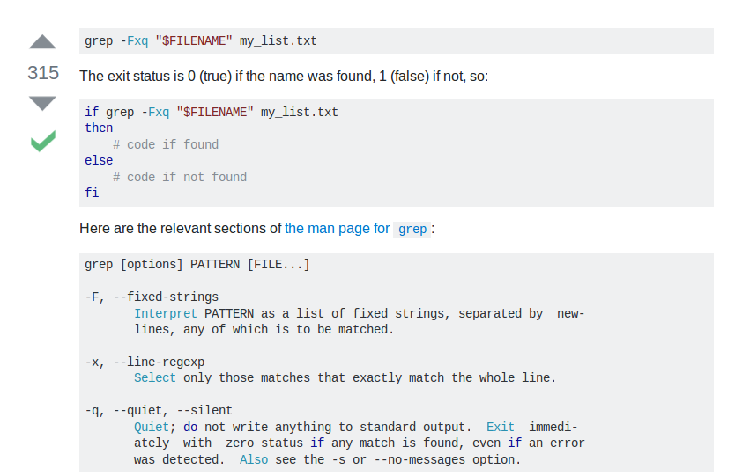
check this link too

http://stackoverflow.com/questions/22861580/bash-script-check-if-a-file-contains-a-specific-line

- how to delete a line containing a string from a file
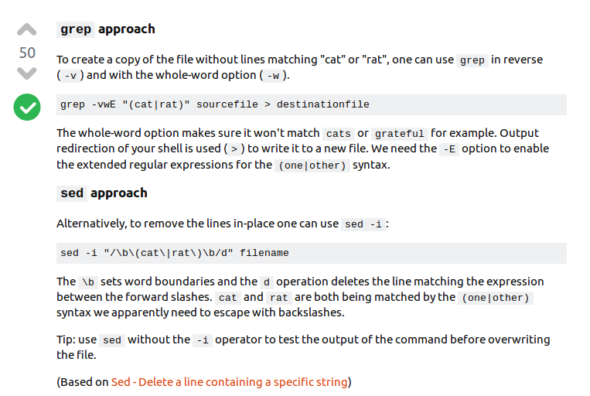
- how to find and print whether a string is present in a file or not
if found print “FOUND”
else print “NOT FOUND!!”

->to compare two strings in the if statement use this syntax(with every other syntax it doesnot work):
if [ $s1 == $s2 ]

